Online Help Requirements - Workshop Minutes
Prepared by Nancy Zacks, Sr. Information Architect, Dynamic Diagrams/ingenta.

Day 1 - Introductions (AM), Collect Functional Requirements (PM)
Requirements were gathered by asking the following questions of the SLB technical writers. These were recorded in a spreadsheet, and also presented to the senior management on the last day of the workshop in the form of a PowerPoint presentation.

Associated Files
These minutes refer to a spreadsheet WORKSHOP.XLS and a PowerPoint presentation created during the workshop. Please refer to these documents for detailed notes.

Welcome/Introduction
- Purpose of the workshop is to gather requirements for the online help documentation display system.
- EDMS is part of the Operations 2000 initiative
- Hard copy and online HTML training is ready. The missing piece now is online help in one repository for display on multiple platforms.
- The Training Help Group requires online help content as part of their work.
- System commercialized, and goal is to have it ready by December.
- A key goal of the meeting is to separate the "must haves" and "nice to haves"
- Vendor strategy - SLB to select vendors to build necessary technology using off-the-shelf tools where possible.

Consultants
- Authoring System - Arbortext
- DTD - Isogen
- Visual design of user interface - Dynamic Diagrams/ingenta
- Operations 2000 depends on moving toward XML.

Schlumberger Personal Introductions (AM)
Please see WORKSHOP.XLS, Attendees for the contents of this spreadsheet.

Introduction of Schlumberger senior managers, writers and consultants.

Introduction of writers.
- Writers' LDAP ID
- Product
- Configuration management system
- Help systems used
- Platforms supported
- Number of help developers in group
- Current online help products

Online Help Requirements Discussion (PM)
This discussion was driven by questions designed to elicit requirements from the technical writers. The goal of this discussion was to uncover as many online help requirements as possible without dwelling on implementation details. Nancy Zacks of Dynamic Diagrams led the discussion. Dirk Beth of Arbortext took notes on this discussion. Please see WORKSHOP.XLS, Questions and Notes for details.

Who will use the help?
- Geologists
- Geophysicists
- Reservoir engineers
- Technical support group
- Sometimes training group
- Corporate decision makers
- Schlumberger customers
- Internal AND External users
- What Users Want
Internal users like windows help viewer because it works. Some clients don't have browsers.

In what environments will the help be used?
- Remote offices and remote field locations
- Some places with low bandwidth communications (less than 64k). Some places have poor communications infrastructure
- Handheld devices with full applications and PDA interfaces that direct equipment remotely
- Help is usually delivered with software but sometimes separate.

How is the Help Used?
- Quick reference to procedures
- Detailed conceptual information in book form
- System shortcuts
- Learning a work process (workflows)
- As a source for training (training group is help group "customer")
- Help is linked to software applications AND delivered separately. Also, there are links between "context-sensitive" help and "book-type" help.

What are some typical task scenarios?
- Data acquisition and analysis software for geophysical applications
- View, manage and analyze and publish data (visual models, seismic data, business information)

Online Help Display Requirements
The results of this discussion appear in WORKSHOP.XLS in the UIR (User interface requirements section). Help requirements were divided into these categories:
- Navigation
- Windows features and behavior
- Printing
- Graphics Support
- Cross Platform Display
- Programming Languages used in applications
- Conversion requirements
- Dynamic updating
- Look and Feel

Online Help Examples
Dynamic Diagrams (Nancy) presented some examples of online help viewers
- Sun Microsystems online support documentation web
- Thinkpad user guide

Requirements Recap/General discussion
- Display system must display application-related (context sensitive) and book-type help.
- Display system must support access from the software application and from a "Bookshelf"- master table of contents across documentation sets and set collections.
- Color and Space Requirements- Many of the software applications have heavy color and resolution requirements for running visualization software. Help display system must use a minimum amount of color and pixels. Applications are very display intensive. Examples: Procedures, flow diagrams, large images, visualization applications.
- UNIX - Many of the applications run in UNIX environments where display standards are not similar.
- Usability - Usability is designing a system or product so that it meets the user's needs. The best way to ensure usability is to understand users, their conceptual models and the environments in which they operate, and design systems accordingly.
- Levels of Doc
- Collection (group of document sets by product)
- Document Set (suite of documents for a product)
- Single Document (help system for one product)
(Right now, using drop-downs to navigate these)

General Design Issues
- Room for content is the most important thing. Job is to display documentation.
- Readability is very important (some systems use 3D cards that reduce resolution. Viewing ingenta.com on this workstation (UNIX) made text unreadable).

Side Issues
These issues were related to the implementation of the EDMS, but not within the scope of this week's Help Workshop.
- Configuration management - version control and multiple author requirements in the system
- Error tracking - how to keep track of the status of errors reported against the documentation
- Workflow management - What types of workflow management will be supported in the system?
- XWD - How to convert existing images that are captured in the Frame screen capture format (.xwd).
- FOSI authoring interface - widely disliked.

Discussion about support for context-sensitive APIs
A key goal of the EDMS is to preserve the current software code uses to link context sensitive online help topics to their associated software. Typically, this mechanism involves a Topic ID that maps to a code in the software, or the ID may actually be included in the software code. It will be very costly to re-tool, or change the software used for context sensitive help linking. Current APIs in use are FrameViewer and WinHelp.

Day 2 - Assign Priorities to Requirements (see below for prioritized requirements)
Please see 6 Summary of Priorities, and WORKSHOP.XLS, UIR for priority ratings listed chronologically. Please see presentation.ppt for priority ratings listed by priority.
After gathering, discussing and documenting the requirements on Day 1, Day 2 was devoted to assigning priorities to the requirements. The following section summarizes requirements by priority. Priority definitions were as follows:
- Priority 1 - Existing feature to preserve or "show stopper"
- Priority 2 - Important, but negotiable
- Priority 3 - Nice to have
Different Requirements among writing groups - It was stated that different writing groups have different requirements, and therefore different priorities for platform support. However, all writers agreed that clear, usable content display was a requirement for everyone.
Cost and Time - There was a discussion about the timeframes and cost of implementing the EDMS and it was re-iterated that the writers did not want to lose any of the display functionality currently available in FrameViewer, WinHelp and other existing display systems.

Day 3 - Software Architecture Overview, Help Display products, and Summary

Software Architecture Overview

EDMS consists of authoring system, content management system, and display system as shown below:
- Authoring System - EPIC from Arbortext
- Content Management System - SigmaLink from empolis
- Delivery System - E3 from Arbortext
- Data is stored as XML and translated to HTML via XSLT stylesheets.

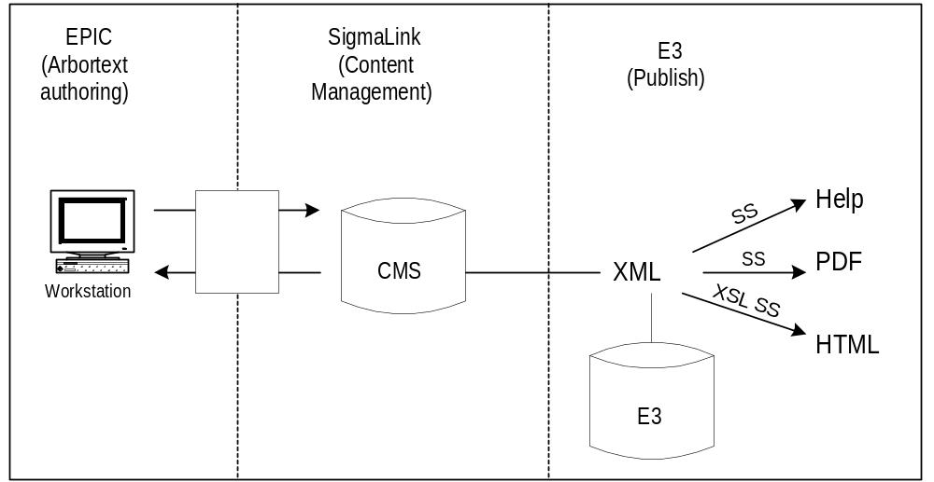

Off the Shelf Help systems

Off -the-shelf display systems
Arbortext presented pros and cons of available help systems in according to how they meet the requirements gathered on Wednesday. (Please see TECHREVIEW.XLS). The spreadsheet presents
- JavaHelp
- HTMLHelp
- WinHelp
- InterHelp
- WebHelp
- HTML
- It will be difficult to obtain a "one viewer fits all system" for all platforms from existing off-the-shelf products
- Selecting one or the other product will involve different trade-offs depending on the viewer.
- Writers stated that it is very important not to lose existing functionality when moving to a new display system. Julia cited FrameViewer capabilities. Mai-ann cited WinHelp capabilities.
- Arbortext will do more analysis. It is likely that more than one display system is needed to meet the multiple platform and non-browser requirements.

Summary of Priorities

Priority 1

Table of Contents

Topic level TOC (TOC for topics relating to one application or book)

Document set TOC (TOC for topics relating to one document set or set of books)

Bookshelf collection TOC (TOC for topics relating to a collection of books)

Expand and collapse TOC

Ability to manually create and order a TOC (authoring)

Reference the same topic multiple times in a TOC

Browse by topic

Searching

Fulltext search

Search by string

Annotations

Private annotation

Public annotation

Annotation management

Drill down

2-3 levels

Drill up (see TOC requirements)

Sequential navigation

Previous and next within topic sequence

Ability to navigate sequences of topics

Display

Multiple windows at once

External links to other doc outside of current window or application

Additional windows for displaying large graphics

Image maps in graphics

Default size and location set by author

Ability to change default per session

Remember location of last window position per session

Misc Priority Items

64K bandwidth or lower

PDA delivery

Bookmarking

Conversion Requirements

Must retain existing ID linking systems

Cross references

Display mechanism

Low maintenance

Low cost

Low color requirements

Minimum weight required to display the help

Cannot affect application performance

Dynamic updating over internet

Delivered over web

Synchronize InTouch and Online help content

Index for one document (as opposed to multiple documents

Click history for sessions

Priority 2 Items

Must allow folders and single topics at same level

Document search - list of relevant documents

Boolean searches linked to cross document searches

Master index across compiled documents

Interactive editing of index terms

Master index across compiled documents

Priority 3

Search on metadata (author)

Search on search (subsearch)

Ability to save and retrieve doc searches

Constrained search by topic area

Conditional text (hide or show text depending on author-controlled requirements)

Natural language searches

Dynamic screen captures (including animation)

For windows behavior - ability to save preferences across sessions (user)

Additional Items

Printing

Print topic

Print a group of topics from an application

Graphics Standards

Would like to standardize on SVG (management)

TIFF, GIF, etc. (see spreadsheet)

Branding

Copyright and logo are required on splash screen, but not on each page.

SLB logo is too large to display on each page (it has color separations for print)

Copyright

Use of Color - must be minimal and cannot interfere with application's color use

Use of Space - content area is most important.

Related Issues

Configuration management and version control

Error tracking and reporting

Workflow management (electronic)

Conversion - Expense, labor, file types (.xwc)

Authoring FOSI widely disliked. Modular design based

on group preferences

Some SLB groups do not have technical writers. They use contractors or engineers write the doc. These documents will need to be cleaned up before they can be displayed. Contractor to convert to XML template.

Graphics Format Discussion
During the presentation, there was a discussion of plans for supporting SVG, which is a proposed W3C standard that supports scalable vector graphics. SVG is written in XML.

Meeting Follow-up

PDF - there was a discussion of the uses of PDF as a document display system. Although PDF provides links and TOC, it is very large and therefore not a good solution for low bandwidth requirements.

Progress reports on deliverables from contractors - contractors reviewed deliverables.
Arbortext - Functional Spec
D/D - Minutes of the workshop

Open Issues as of 9/7/01

Arbortext investigating a strategy for addressing cross-platform display requirements.

Specific PDA requirements

